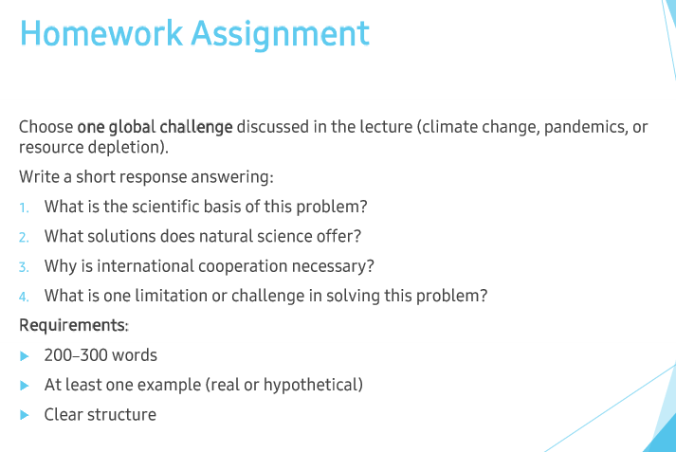

Over the past few decades, people have been using natural resources whenever they need. Although they can provide several benefits, it is clear that the amount of resources is limited. In this essay, I will discuss what natural science can offer to tackle the resource depletion issue and the limitations in solving the problem.

Natural science can play a crucial role in addressing the resource depletion issue. For instance, developing a sustainable energy system can contribute to the issue since it is possible to generate energy nearly infinitely. Although they do not seem cost-effective at this moment, scientific breakthroughs could happen at some point, which can lead people to use energy without concern. In addition, it is of note that the chance of finding alternative ways of generating energy is reasonably high enough. People did not fully understand when it comes to natural energy, because of the complexity of how nature works.

However, it is naïve to believe that natural science could solve everything since they do have limitations. First and foremost, human errors could happen in every research, and natural science is not an exception. Although the scientific method could handle several errors given the fact that they value reproducibility the most, it is still up to humans to interpret a result. Secondly, nature is simply too vast to research, in other words, it is impossible to fully comprehend nature ever.

To sum up, although natural science has the potential to solve global challenges, it is not possible to solve every problem.

